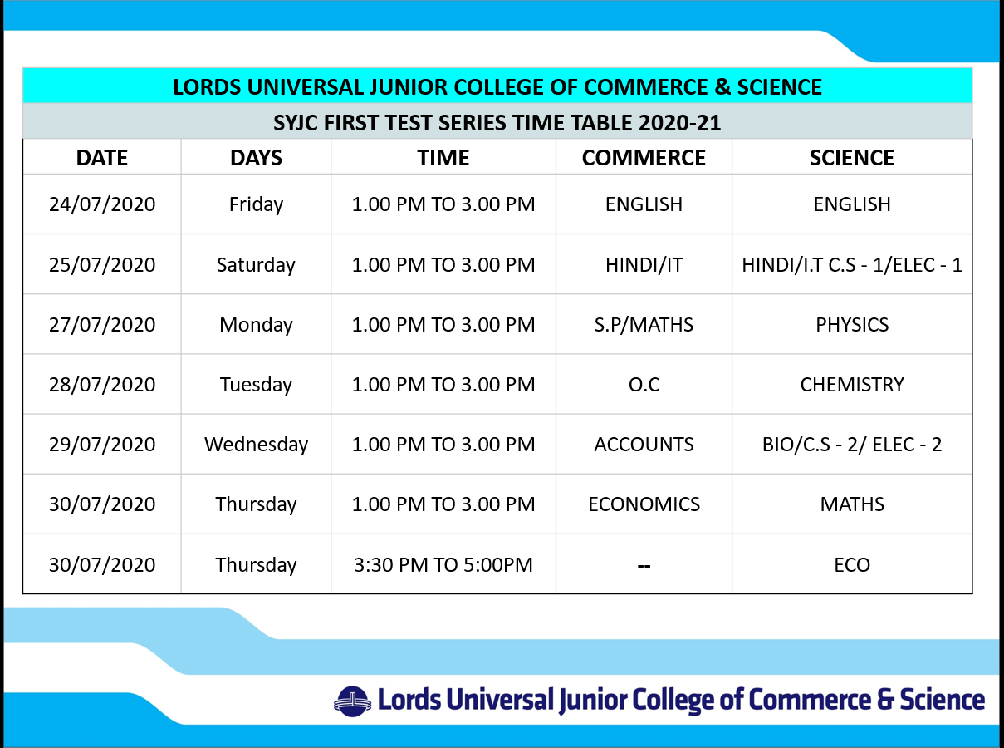
Instruction for Online 1ST TEST SERIES.
Before the exam
- Mark Your Attendance in the Chat box,
- Appear for exam between 1 pm to 3 pm
- Student must keep track of time, as no clock or time notification is provided on our exam portal.
- Keep sufficient power / electricity backup.
- Laptop / Mobile Phones must be fully charged
- Use faster, reliable and continued internet connection
- Close all programs, including email
- Click on the exam link provided in the Google Classroom from The College.
- Login Key is activated for single attempt. If you face any difficulty inform the Class Teacher without any delay.
- To begin the exam, click on the link.
During the exam:
- The student may not use his or her textbook, course notes, or any other outside source.
- Students must complete the exam within the time frame allotted for the exam.
- Students must not stop the session and then return to it
- Student face internet of power failure problems inform the class Teacher immediately.
- If questions are not visible refresh the page.
- You have to type the answers in the respective text box approved.
- For fill in the blanks, rearrange and short Q/Ans. Type of Questions
- For true and false, MCQ1, MCQ2 And MCQ3, you have to click the correct answers.
- After attempting all the questions and click submit button, click on finish test button

What to do if your online exam is interrupted
- If your online exam is interrupted, click the “Back” button on your web browser to see if you can return to the exam. If not get in touch with your class Teacher immediately
- After the exam
- Kindly Make sure that you click on the submit button
- Inform in the chat box that you have submitted the Answer Paper.

